Extraction in detail, Delta Mechanisms and few challenges faced during implementation

**Summary:**

The article articulates the step by step procedure for the generation of the COPA Data Source at the ECC R/3 back-end level along with Delta mechanisms and talk about the few challenges faced while extracting the data during implementation.

**Table of Contents:**

1. Introduction

2. Following is the Scenarios with explanation:

     a. Generating the COPA Data Source,

     b. Issues/Errors faced while extraction and building the Summarization Levels,

     c. Transporting the Summarization Levels to the next level,

     d. Delta mechanism and how it works, and

     e. How to change the safety interval limit for COPA Data Source

3. Describing the Test Scenarios

4. Related content

**Introduction:**

Initially we had generated the COPA Data Source using the standard procedure and while extracting the data in RSA3, unable to extract the data due to few issues at ECC R/3 back-end level. Therefore describing such scenarios in this document.

Terms

|  |  |
| --- | --- |
| Data Source | SAP BW Data Extraction Object |
| T-code | SAP Transaction |
| CO-PA | Controlling – Profitability Analysis |
| Operating Concern | An operating concern represents an organizational unit in your company for which the sales market has a uniform structure. It is the valuation level for Profitability Analysis (CO-PA). |
|  |  |
|  |  |

**Scenario:**

**Part – A). Generating the COPA Data Source:**

Below are the simple steps for generating the COPA Data Source.

Basically COPA Data Source generation is a generic extraction, and we can create the generic Data Source depending on the KPI’s for the Profitability Analysis.

Go to T-Code:

**SBIW** **–>** Settings for Application-Specific Data Sources (PI)**–>** Profitability Analysis**–>** Create Transaction Data Source**–>** Create a Data Source.

or

**KEB0 –>**define the Data Source with the necessary details as below.

Generally, we use the naming convention for the COPA Data Source is: {1_CO_PA_(SYSTEM ID)_(CLIENT)_(OPERATING CONCERN)}.

Select the Operating concern and choose the option **Costing/Account-based** (as per the business requirement), execute (F8).

If the COPA Data Source is “**Costing based”** then it will extract the data from below four tables:

CE1XXXX – Actual line items

CE2XXXX – Plan line items

CE3XXXX – Summary table

CE4XXXX – Segment table

where “**XXXX”** is the Operating Concern.

**Or**

If the COPA Data Source is **“Account based”** then it will pull the data from the following tables:

COEP & COBK – CO Object: (Line Items (by Period) & Document Header)

COEJ – CO Object: Line Items (by Fiscal Year)

COSP & COSS – CO Object: (Cost Totals for Internal & External Postings)

CE4XXXX – Segment table

Ein Bild, das Text enthält.

Example

Select the below fields which you want to display/as a part of the Data Source.

**Note:**When we generate the COPA Data Source basically the Data Structure (Characteristics and Value fields) is based on/proposed by the Operating Concern (OC).

{If we want to check/view the total number of fields based on the Operating Concern and other etc. details. Then, Go to the T-Code: **KEA0.**

The T-Code: **KEA0** is used for to maintain/create the Operating Concern.}

[Ein Bild, das Tisch enthält.
](https://blogs.sap.com/wp-content/uploads/2015/07/untitled1_758977.jpg)

After field selection, check & choose the Info Catalog (F7) option for the Data Source generation.

[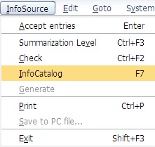](https://blogs.sap.com/wp-content/uploads/2015/07/untitled2_759008.jpg)

Then provide the Transport Request number and select the fields for the input selection.

[Ein Bild, das Tisch enthält.
](https://blogs.sap.com/wp-content/uploads/2015/07/untitled6_759032.jpg)

Click on Save button.

Data Source “1_CO_PA_DS2” created successfully.

**Note:**  After generating the COPA Data Source, we will not be able to edit/enhance the COPA Data Source. In-case if we need to add the new fields, then we need to delete and recreate the Data Source again using the same naming convention.

Go to the T-Code: **RSA3**and try to extract the data.

**Part – B). Issues/Errors faced while extraction and building the Summarization Levels:**

In some situations, you might get the following issues during the data extraction in **RSA3**:

Case. 1: During the data extraction probably you will get **“0”** records in **RSA3**. Or

[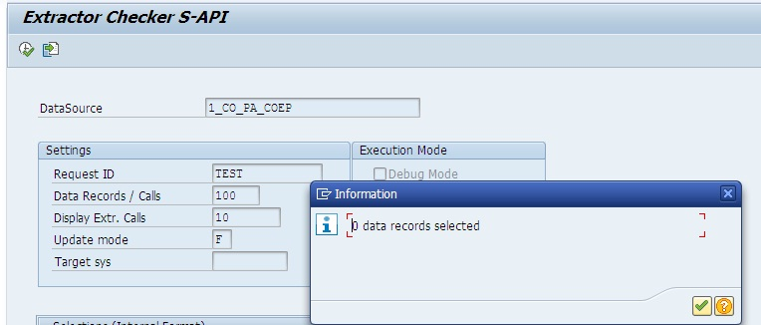](https://blogs.sap.com/wp-content/uploads/2015/07/untitled8_760012.jpg)

Case. 2:  The Data Source is giving a below error while extracting the data in **RSA3**.

‘Errors occurred during the extraction’ (Message no. RJ012).

[Ein Bild, das Text enthält.
](https://blogs.sap.com/wp-content/uploads/2015/07/untitled16_761211.jpg)

or check the error logs.

[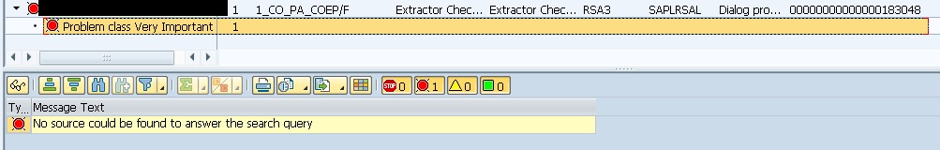](https://blogs.sap.com/wp-content/uploads/2015/07/untitled7_759034.jpg)

To overcome from this error, we need to define/maintain the following few steps.

Go to the T-Code: **KEB0** and check if the Summarization Levels are maintained or not using option**(CTRL+F3).**

[Ein Bild, das Text enthält.
](https://blogs.sap.com/wp-content/uploads/2015/07/untitled29_763167.jpg)

Or go directly to the T-Code: **KEDV**(CO-PA: Maintain Summarization Levels). Select the Operating Concern.

And then, check the Summarization levels are maintained or not. If not, then choose the option to create entries**(F5)**.

[Ein Bild, das Text enthält.
](https://blogs.sap.com/wp-content/uploads/2015/07/untitled20_763085.jpg)

While creating the Summary Levels, kindly consult with your functional consultant for more details/about the requirement.

[Ein Bild, das Text enthält.
](https://blogs.sap.com/wp-content/uploads/2015/07/untitled26_763135.jpg)

Come back and select your Summ. Levels.

[Ein Bild, das Text enthält.
](https://blogs.sap.com/wp-content/uploads/2015/07/untitled25_763134.jpg)

Choose the Characteristics option and assign the characteristic Values ‘*’ or  ‘etc… value’ as below.

[Ein Bild, das Tisch enthält.
](https://blogs.sap.com/wp-content/uploads/2015/07/untitled11_760061.jpg)

Save the entries and assign the TR.

[Ein Bild, das Text enthält.
](https://blogs.sap.com/wp-content/uploads/2015/07/untitled27_763139.jpg)

Now, the status of Summary levels are **Active, without data.**

Then go to the T-Code: **KEDU**(CO-PA: Build Summarization Levels) refill the same using below option.

Select your Operating Concern (AA00), Type of Profitability Analysis “Costing-based (1) or Account-based” (2) and Choose Summarization Level (1 to 2).

[Ein Bild, das Text enthält.
](https://blogs.sap.com/wp-content/uploads/2015/07/untitled30_764270.jpg)

Choose the option **Rebuild/Build new levels** and Execute (F8).

[Ein Bild, das Text enthält.
](https://blogs.sap.com/wp-content/uploads/2015/07/untitled23_763131.jpg)

Again, go to the T-Code: **KEDV** and check the status of Summary levels. now the status is **Active** with data.

[Ein Bild, das Text enthält.
](https://blogs.sap.com/wp-content/uploads/2015/07/untitled28_763141.jpg)

After refilling the Summarization levels, go to the T-Code: **RSA3** and extract the data.

[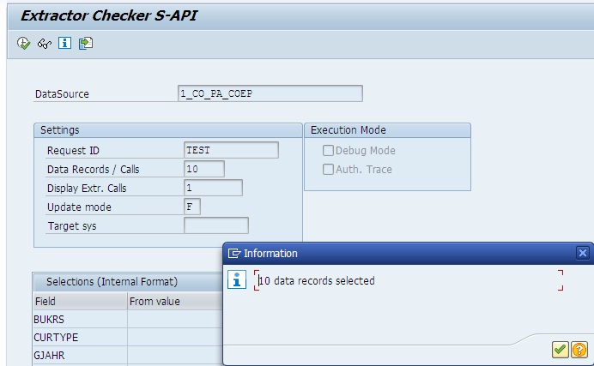](https://blogs.sap.com/wp-content/uploads/2015/07/untitled17_761329.jpg)

If still issue occurs then, go to the T-Code: **SE38** and run the Report program “**RKETREGN**” (Summarization Levels: Generate Tables for Summarization Levels) generate the same.

[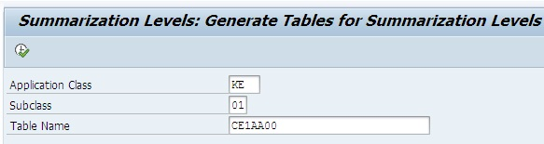](https://blogs.sap.com/wp-content/uploads/2015/07/untitled18_761372.jpg)

And again Go to the T-Code: **RSA3** and extract the data.

[](https://blogs.sap.com/wp-content/uploads/2015/07/untitled17_761329.jpg)

Now data are available.

**Part-C). Transporting the Summarization Levels to the next level:**

Now transporting the changes/settings to the other system/next level. Go to the T-Code: **KE3I** (CO-PA: Transport tool) to collect all settings in the TR.

[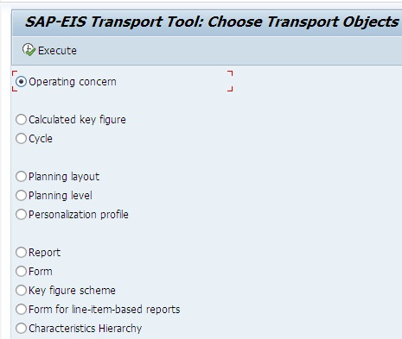](https://blogs.sap.com/wp-content/uploads/2015/07/untitled13_760063.jpg)

Execute **(F8)** it and mention your both TR Customizing and Workbench TR.

[Ein Bild, das Text enthält.
](https://blogs.sap.com/wp-content/uploads/2015/07/untitled14_760076.jpg)

Select the relevant object classes and continue **(OK).**

[Ein Bild, das Tisch enthält.
](https://blogs.sap.com/wp-content/uploads/2015/07/untitled15_760077.jpg)

Release the TR from **SE09.**Go to the T-Code:**SCC1** (Client Copy – Special Selections), basically this T-Code is used for to import the TR from one client to another client within a system, for example: ECCCLNT800 (Pre-DEV) to ECCCLNT900 (DEV/QUA system).

**Note:** Check if the above transport procedure is applicable in your case. Otherwise, follow the normal transport procedure for transporting the objects from one system to another system, for example: from development (DEVCLNT100) to quality (QUACLNT500) system.

**Part-D). Delta mechanism and how it works:**

The COPA Data Source is based BW Delta process type: **“CUBE”** (Info Cube Extraction).

**Note:**The BW Delta process type “**CUBE**” is exactly similar as “**ADD**”.

Explaining the Delta mechanism of **“ADD/CUBE”** with below example and how it works.

[](https://blogs.sap.com/wp-content/uploads/2015/07/untitled5_759010.jpg)

**Example:**

When BW Delta process type: **ADD** **–>** which provides the additive Image.

A simple Doc Number as below: Existing Target document’s quantity value is 30.

|  |  |  |  |
| --- | --- | --- | --- |
| **Document** | **Status** | **Quantity** | **U/M** |
| 11111 | O | 30 | KG |

Now let us assume the quantity has changed from 30 to 40 in the SAP ECC source.

If the Data Source is based on **ADD/CUBE**: it will bring only additive image i.e. quantity as 10.

|  |  |  |  |
| --- | --- | --- | --- |
| **Document** | **Status** | **Quantity** | **U/M** |
| 11111 | O | 10 | KG |

In the final target it will reflect as below: adding the value (30+10 = 40).

|  |  |  |  |
| --- | --- | --- | --- |
| **Document** | **Status** | **Quantity** | **U/M** |
| 11111 | O | 40 | KG |

**Note:** If the data that fills the BI system with an additive (**ADD/CUBE**) image, the data can be written to an Info Cube or a Data Store object.

However, in-case of Data Store object, the update type of key figures must be set to add and not overwrite.

|  |  |  |  |
| --- | --- | --- | --- |
| **Delta Process type** | | **DSO/ODS** | **CUBE** |
| ADD/CUBE | Additive Image | Yes (Add Only) | Yes (Add) |

**Part-E). How to change the Delta safety interval limit for COPA Data Source:**

When data is extracted from the COPA Data Source, a “safety delta” of half an hour (30 minutes) is used with the initialization and the delta upload. This always ensures that only records that are already half an hour old, since the start of the upload are loaded into SAP BW. Half an hour was chosen as the safety delta to overcome any time differences between the clocks on the different application servers.

[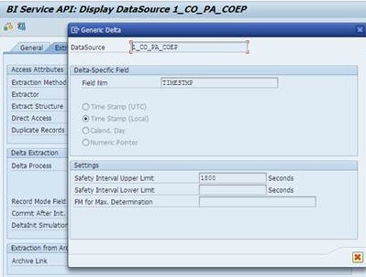](https://blogs.sap.com/wp-content/uploads/2015/07/untitled4_759009.jpg)

The above standard upper limit for COPA is already set to 1800 i.e. (30 Mins) provided by SAP.

Steps for changing the Delta Safety intervals for the COPA Data Source:

**Note:** It is not recommended to change the safety intervals. But sometimes we need to change the Intervals based on the Business/Project requirements.

Go to the T-Code: **RSA2**, check the existing value.

[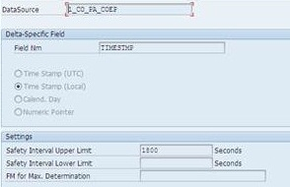](https://blogs.sap.com/wp-content/uploads/2015/07/untitled44_765201.jpg)

The Data Source safety upper limit is: 1800.

Also, we can check the interval values for individual Data Source in the table **“ROOSOURCE”**where the field **“DELTASAFE2”** holds the Safety Upper limit Value and “**DELTASAFE1″**holds Lower limit.

[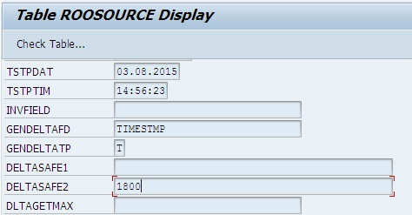](https://blogs.sap.com/wp-content/uploads/2015/07/untitled31_764260.jpg)

Below are the simple steps for changing the safety interval limit value.

Now, again Go to the T-Code: **SE11**, open the table “**ROOSOURCE”**and select the Data Source, click on display button.

Then we will use the ABAP Debugging trick to change the interval value.

[Ein Bild, das Text, Tisch enthält.
](https://blogs.sap.com/wp-content/uploads/2015/07/untitled33_764329.jpg)

Select the relevant field and press **Enter** button **–>** Double Click on the **CODE**and replace the word “**SHOW**” with “**EDIT**” **–>** press **ENTER** –> Execute**(F8)**.

It will open in edit mode, then change the value based on the requirement (for example: here replacing 1800 Seconds with 600), save and go back to check the changed value in the table/Go to the T-Code: **RSA2.**

**[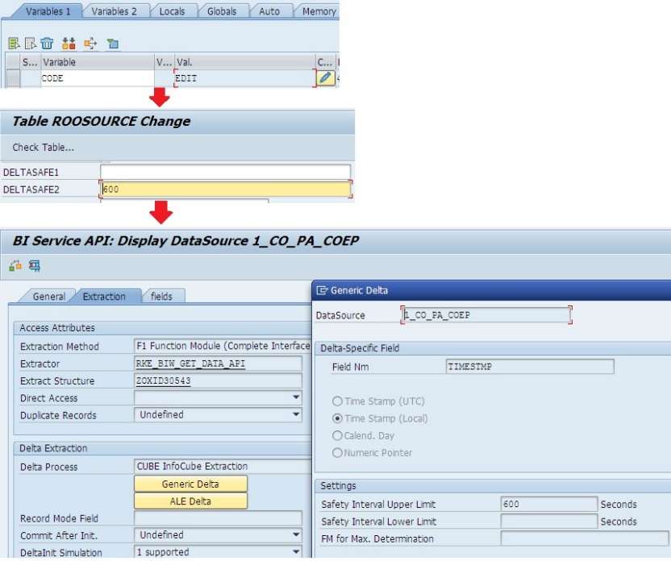](https://blogs.sap.com/wp-content/uploads/2015/07/untitled34_764337.jpg)**

Refer SAP Note: (0000392876 – Safety delta for extraction from the CO-PA)for more details.

Replicate/Import the Data Source in the BW/etc. Targets (Destination) and load the data into respective Data Targets.